**User Manual of Witness Page:**

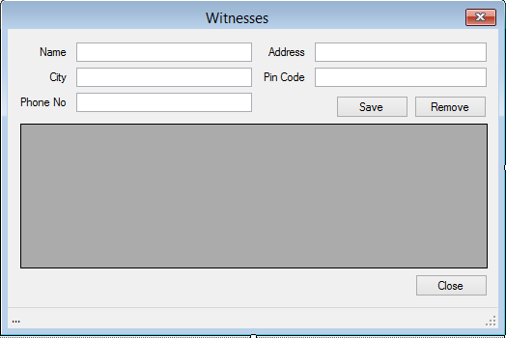

* **This is a witness form through which user can store the details of witnesses of the particular case.**